## Exercise 2.3.6: Add to Calendar

Using only JavaScript, add a list item to the Calendar that you need to complete from your list of chores.

For example, if you need to clean your room, you might add:

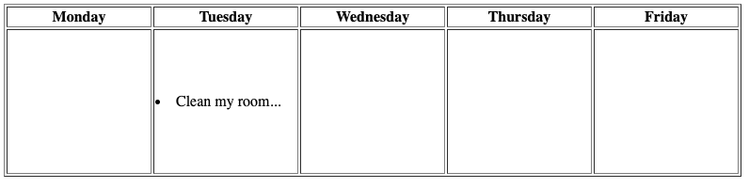

**Challenge:**

In addition, try adding a new row to the calendar using only Javascript. You can do this by creating a new tr element and appending td elements as children.

*Hint:* The table isn’t technically considered the parent element of the tr, the element tbody is. This isn’t shown in the table in the editor, but shows up when inspecting it in the console.